Lab05 – Afra Al-Marri – 201903378

B1 Define the system boundary and identify actors - 10 minutes
Boundary Statement:
All Phone Shop (APS) is responsible for client registration, phone listing and sales, the product catalogue, fixed-price actions, auction and bidding, and invoice management. APS store the relevant registration, item, sale, and invoice information. Client payments and financial accounts are handled by PoB, while login operations are outside the scope of APS.

Actors:
Client: register, sells, buys and bids, and it has two specializations (individual client, Corporate client).
PoB: is advised of new registrations, removals and penalties, and informs Aps with payments.
B2 Build the use case inventory - 25 minutes
Id and name | Actors | Successful outcomes | Case evidence
UC001 Register client | Client, PoB | Registration created with a unique number, PoB advised | “creates a registration, assigns a unique registration number”
UC002 remove registration | Corporate client, PoB | Registration removed, PoB informed | “can only be removed by corporate clients”
UC003 sell item | client | Item and sale info are recorded, an item id is assigned and attached to the client registration | “The client has the option to sell the item either on auction (bidding), or on fixed price sale”
UC004 add item to the catalog | Client | Approved image put in the catalog | “displays the item for sale if approved by the client”,” Once the client approves the display image, APS includes it in its product catalog”
UC005 remove item | Client | The item is removed after display but before its sold | “Clients can also remove their items after display but before sale”
UC006 buy fixed-price item | Client | Basket saved, checked out, item marked sold | “creates a shopping basket for the selected item(s). The system saves the shopping basket and attaches this with the client registration. The client then checks out”
UC007 buy item on auction | Client | Valid Bids are recorded, when the auction ends the last bidder is notified | “clients can bid a price for the selected item before the end of auction time”
UC008 make invoice | Client | Invoice confirmed and saved as unpaid | “attached with the client registration with the status “unpaid””
UC009 issue penalty | Client, PoB | A 10% penalty is charged and the penalty advise is sent to PoB | “PoB informs APS with the client registration number and the invoice number”
UC010 advise PoB of penalty | PoB | PoB receives the penalty advice | “an advice on this penalty is sent to PoB, and the sale is cancelled by APS”

B3 Draw and refine the diagram - 35 minutes
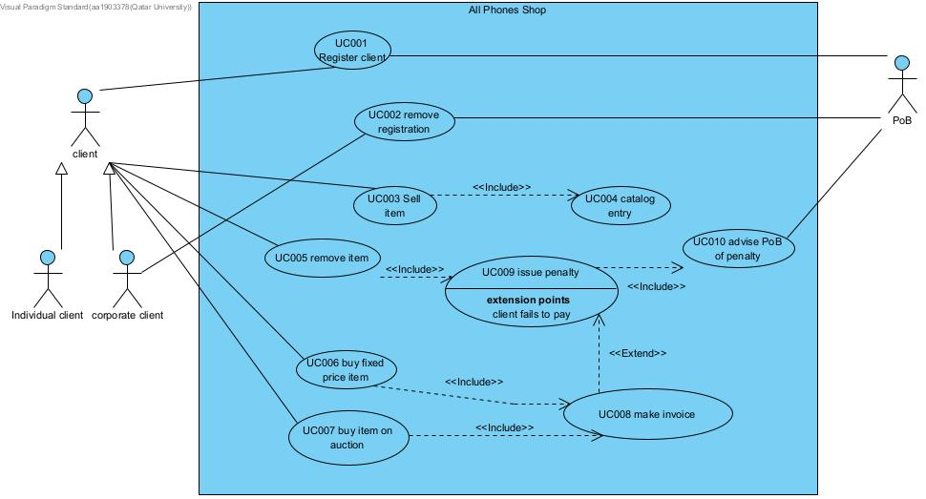

Type | Candidate elements | Use or omit and why
Include | UC003 Sell item →UC004 Catalog entry | Selling an item requires the item to be entered into the catalog before it can be displayed for sale.
Include | UC005 Remove item →UC009 Issue penalty | Removing a displayed item before sale requires the penalty to be issued.
Include | UC009 Issue penalty → UC010 Advise PoB of penalty | When APS isse a penalty PoB must be advised.
Include | UC006 Buy fixed-price item → UC008 Make invoice | Fixed-price purchase requires APS to prepare an invoice.
Include | UC007 Buy item on auction → UC008 Make invoice | A completed auction purchase also requires APS to prepare an invoice.
Extend | UC009 Issue penalty → UC008 Make invoice | The penalty occurs only if the client fails to pay.
Generalization | Individual Client → Client  Corporate Client → Client | They are specialized types of client and inherit the common client iteraction.

